REPORT ON OUR EVENT
Practical Workshop on Encryption Techniques for Junior Software Developers.
Team: Amiratu Ewurabena Sarkodie Abubakari
Wayne Kwabi Stephen
ABSTRACT
This report describes a 4hr practical workshop conducted for junior software developers on the fundamentals of encryption, focusing on how it operates at the computer level and its applications in software systems. The session introduced key concepts such as plaintext, ciphertext, and cryptographic keys, with emphasis on the Advanced Encryption Standard (AES). Using Python and installed cryptographic libraries, participants were guided through the process of implementing AES encryption. The workshop combined theoretical explanations with hands-on practice, allowing participants to understand how data is transformed into a secure format. By the end of the session, all participants who followed the steps successfully developed a mini-AES encryptor, demonstrating a clear understanding of basic encryption principles and their practical use in software development.

INTRODUCTION
Encryption is a fundamental technique used in computer systems to protect data by converting it from a readable format into an unreadable format using cryptographic algorithms and keys. At the computer level, this involves a series of logical operations that transform data into a secure form, ensuring that only authorized parties can access it.
The workshop was initially planned for senior software developers; however, due to unforeseen circumstances, the session was instead conducted with junior developers. This shift required an adjustment in approach, with a stronger focus on foundational concepts and simplified explanations to ensure effective understanding. The session introduced participants to the core principles of encryption and its importance in real-world software development, particularly in securing user data and communication systems. The Advanced Encryption Standard (AES) was used as the primary case study to demonstrate how encryption works in practice. Through a combination of explanation and hands-on implementation using Python and cryptographic libraries, participants were able to explore how encryption operates at the system level and how it can be applied in building secure applications.
OUR OBJECTIVES
The main objectives of the workshop were:
- To introduce junior software developers to the fundamental concepts of encryption
- To explain how encryption works at the computer level
- To demonstrate the use of the Advanced Encryption Standard (AES) in securing data
- To provide hands-on experience using Python and cryptographic libraries
- To enable participants to implement a simple encryption program
- To highlight the importance of encryption in real-world software development and data security
BACKGROUND
We first decided to provide a foundational understanding of encryption, focusing on how it operates at the computer level using the Advanced Encryption Standard (AES). Encryption was introduced as the process of converting plaintext into ciphertext using a key, ensuring that sensitive information remains secure.
A key part of the session was explaining how data is represented inside a computer. Participants were introduced to bits and bytes, and how plaintext is broken down into binary form before being processed by encryption algorithms. This helped bridge the gap between abstract concepts and actual computer operations.
The AES algorithm was then explored in detail. It was explained as a symmetric encryption technique that processes data in fixed-size blocks through multiple transformation rounds. Each round applies a series of operations designed to obscure the original data.
The main stuff about AES covered included:
- Sub Bytes (S-Box): Participants learned how the substitution box (S-Box) replaces each byte with another value to introduce non-linearity and increase security.
- Shift Rows: The process of shifting rows in the data matrix to create diffusion was briefly discussed.
- Mix Columns: This step was explained as a transformation that mixes the data within each column using mathematical operations, making patterns harder to detect.
- Add Round Key: Emphasis was placed on how a round key is generated and combined with the data using bitwise operations to further secure the encryption process.
This was to help them gain insight as to how the computer breaks down the plaintext and how it becomes an unbreakable ciphertext.

TOOLS AND TECHNOLOGIES USED
The workshop utilized Visual Studio Code (VS Code) as the primary development environment and Python as the programming language for implementation.
To support the encryption process, relevant cryptographic libraries were installed in Python, enabling participants to implement AES encryption efficiently without building the algorithm entirely from scratch. These tools provided a practical and accessible setup for demonstrating encryption concepts and developing a mini AES encryptor.
Methodology
The workshop combined interactive teaching with hands-on practice to help participants understand encryption effectively.
First, the concept of AES round keys was explained using a marker and board, showing step by step how the keys are added during encryption. Participants followed along visually to grasp the process.
Next, a live coding session was conducted where we demonstrated AES implementation in Python. Participants then practiced coding on their own computers, using VS Code or PyCharm, applying what they had learned to create a mini AES encryptor through a step by step procedure as I wrote on the board each line of code since we lacked projectors.
The session concluded with a question-and-answer segment, allowing participants to clarify doubts, discuss challenges, and solidify their understanding of the encryption concepts and implementation.
IMPLEMENTATION
The implementation phase focused on applying the concepts of AES encryption using Python. Participants followed a step-by-step process to develop a simple AES encryptor using installed cryptographic libraries.
The demonstration began with defining the plaintext input, after which the encryption process was implemented using a secure key. The program then converted the plaintext into ciphertext, illustrating how data is transformed into an unreadable format. A decryption step was also included to show how the original data can be recovered using the correct key.
Screenshots were taken throughout the process to document key stages, including code setup, encryption output, and successful decryption. These visuals provide evidence of the practical work completed during the workshop and support the explanation of the implementation process.
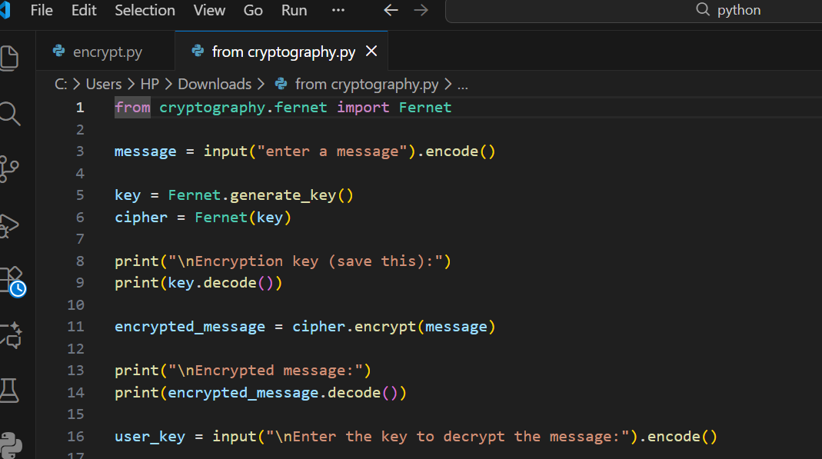
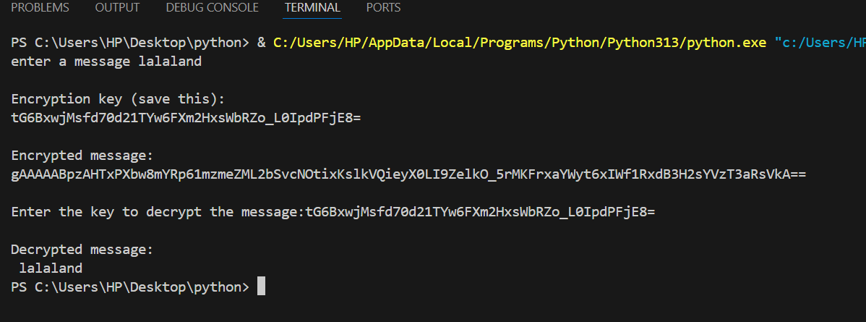
Overall, this phase allowed participants to translate theoretical knowledge into a working program, reinforcing their understanding of AES encryption.
OUTCOMES
The workshop was successful, as participants understood the core concepts of AES encryption and how it works at the computer level. Through the hands-on session, they were able to follow the coding process and apply what they learned.
By the end of the workshop, participants who followed along successfully created a mini-AES encryptor, demonstrating both practical skills and improved understanding of encryption in software development.
CHALLENGES ENCOUNTERED
Several challenges were encountered during the workshop. Firstly, there was some change of plans as some senior developers had to go somewhere and we had to change a lot of stuff because we were to work with the junior developers now. Also there were no projectors available, which made it more difficult to visually demonstrate concepts to all participants at once. Secondly, the environment was quite hot, affecting overall comfort and concentration.
In addition, poor network connectivity caused delays in downloading the required cryptographic libraries. Some participants also experienced issues with slow or unresponsive laptops, which affected the pace of the hands-on coding session. Despite these challenges, the workshop was successfully completed.
CONCLUSION
In conclusion, our workshop successfully introduced junior software developers to the fundamentals of encryption, with a focus on AES and its operation at the computer level. Despite some challenges, participants were able to understand key concepts and apply them practically using Python.
The hands-on approach proved effective, as participants were able to develop a mini AES encryptor by the end of the session. Overall, our workshop highlighted the importance of encryption in software development and provided a solid foundation for further learning in secure coding practices.
REFERENCES
- Py Crypto dome Documentation. Cryptographic Library for Python.
- National Institute of Standards and Technology (NIST). Advanced Encryption Standard (AES).
- A lot of YouTube videos.
- Lecture notes from Dr. Affum
LINKS TO THE VARIOUS PLATFORMS
  - LinkedIn
1.https://www.linkedin.com/posts/wayne-stephen-a089412ab_eventday-cyberaes-softwaredevelopers-activity-7444869764105035776-E5Or?utm_medium=ios_app&rcm=ACoAAEq2LGgBbzbFh21xPVm7U5KxX3D-sNQSinA&utm_source=social_share_send&utm_campaign=copy_link
2.https://www.linkedin.com/posts/amiratu-sarkodie-4b7a063b9_eventday-cyberaes-softwaredevelopers-ugcPost-7444880510306250752-Nhl1?utm_source=share&utm_medium=member_ios&rcm=ACoAAGYhc0sBJcoED7-94MbR6dZJwFCZ49TEDJc
- Website
https://mediaweb.shooterzbarandgrill.com/
- Youtube

